PROJECT REPORT
STUDENT RECORD MANAGEMENT
SYSTEM(SRMS)
Prepared in partial fulfilment of Project-Based Learning Course:
CSE 201 – Coding Skills

Submitted by
P.SRIVEDA AP24110011270
N.YOSHITHA AP24110011292
SK.TAKHREEM AP24110011299
M.SUMANVITHA AP24110011366
P.KOUSHIKA AP24110011375
CSE, SECTION H
2024-2028


SRM UNIVERSITY-AP
Andhra Pradesh
December-2025

ABSTRACT
The Student Management System (SRMS) using C Programming is a consolebased application designed to manage student records efficiently through secure role-based access. The system provides three types of users—Admin, Staff, and Guest—each with specific permissions to ensure controlled data handling. It uses file handling techniques in C to store, retrieve, update, and delete student information without the need for a database.
The primary objective of the system is to simplify student record maintenance by supporting essential operations such as adding, displaying, searching, updating, and deleting data. The authentication module ensures that only authorized users can access or modify information, thereby improving security and reliability.
This project demonstrates the practical application of modular programming, file operations, and authentication mechanisms in C. It offers a lightweight, portable, and user-friendly approach to student data management, making it suitable for small-scale educational institutions or learning environments. Ultimately, the system provides an organized and efficient method to handle student information while showcasing fundamental concepts of the C language.

TABLE OF CONTENTS
1.INTRODUCTION…………………………………………………………………………4
2.OBJECTIVES……………………………………………………………………………..4
3.MODULES………………………………………………………………………………...5
4.METHODOLOGY…………………………………………………………………………6
5.DATA FLOW DIAGRAM………………………………………………………………….7
6.IMPLEMENTATION……………………………………………………………………… 8
(a)Login Menu………………………………………………………………………………8
(b)Main Menu…………………………………………………………………………….....9
(c)Add Student……………………………………………………………………………..10
(d)Display Student…………………………………………………………………………11
(e)Search Student…………………………………………………………………………..12
(f)Update Student………………………………………………………………………….13
(g)Delete Student…………………………………………………………………………..14
7.CODE&OUTPUTS………………………………………………………………………..15
8.CONCLUSION……………………………………………………………………………15

INTRODUCTION
Managing student information manually can be time-consuming and error-prone. To overcome this, a simple yet effective computerized system is necessary.This project is a console-based Student Management System that allows authenticated users to perform various operations based on their assigned role.
The system stores data in text files (students.txt and credentials.txt) using sequential file handling. This makes the application lightweight and easy to run on any system without requiring a database.
The project focuses on User authentication, Role-based access, CRUD operations on student data, Effective use of file handling techniques in C.This system is ideal for small institutions or learning environments where a simple student record system is required.

OBJECTIVES
- To build a secure and reliable student management system using the C programming language.
The system aims to provide a dependable platform for storing and managing student records with accuracy and consistency.

- To implement an effective role-based authentication mechanism.
By distinguishing users as Admin, Staff, and Guest, the system ensures controlled access and protects sensitive data from unauthorized modification.

- To utilize file handling techniques for efficient data storage and retrieval. The project showcases how C file operations can replace manual record-keeping and enable fast, structured handling of student information.

- To design a fully functional module for student record operations.
The system enables adding, displaying, searching, updating, and deleting records to simplify academic data management.

- To create a user-friendly, menu-driven interface for easy navigation. The objective is to make the system accessible and simple for all types of users, regardless of technical expertise.

- To develop a modular and maintainable codebase that follows good programming practices.
Separating functionalities into independent functions increases readability, reduces errors, and makes future enhancements easier.

MODULES

The Student Management System is divided into several clearly defined modules. The major modules are as follows:

1. Login & Authentication Module Reads username and password
Verifies credentials from credentials.txt
Identifies user role (admin/staff/guest)

2. Menu Module

Displays the main menu based on the user’s role and provides navigation to all system functions.
- Admin Module
Admin acts as the highest-level user.
- Staff Module
Staff has limited permissions
- Guest Module
Guest has only view permissions

3. Student Record Module

Manages student details such as adding, displaying, searching, updating, and deleting records.

- Add Student (Writes roll number, name, and marks to file).

- Display Students (Reads and prints all stored records).

- Search Student (Finds a student by roll number).

- Update Student (Modifies name or marks of existing student).

- Delete Student (Removes a student by copying all others into a temp file).

4. File Handling Module

Stores and retrieves data from text files to ensure permanent record-keeping.

5. Validation & Error Handling Module

Checks input accuracy and manages invalid operations, missing files, or wrong entries.

6. Logout & Exit Module

Safely exits the system, clearing current user details and ending the session.

METHODOLOGY
The development of the system follows a structured sequence of actio to handle student data reliably:
- When the application is launched, it first checks login requirements.The
user must enter valid credentials before accessing any feature.

- The credentials are compared with stored entries in a file.Only if the match is correct will the system continue.

- After login, the user is shown a role-based menu.Each role is presented
with specific choices such as add, view, search, edit, or delete.

- On selecting an option, the associated function is called.Each function is written separately to make the program more organized.

- The data needed for the operation is read from or written to text Files.These files act as the storage unit for all student records.

- The program then displays the output of the selected action.Details are shown on the console so that the user can see the result immediately.

- This process continues in a loop until the user decides to log out or exit
the system, after which the program terminates safely.

DATA FLOW DIAGRAM
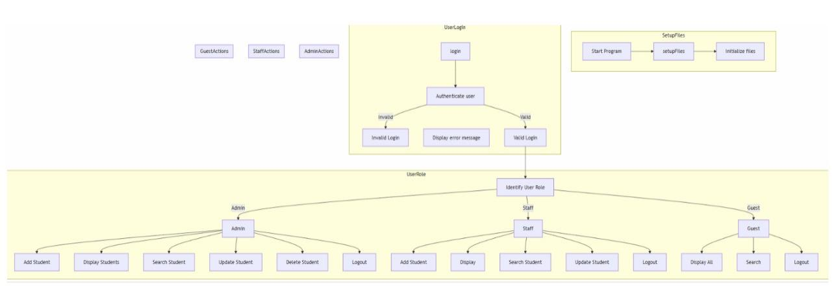

- Program Initialization:
The system begins by executing setupFiles(), which checks and creates the necessary data files to ensure the program is ready for use.

- User Login:
Users log in through login() by entering their credentials.
- If the credentials are invalid, access is denied and an error message is displayed.
- If the credentials are valid, the system verifies and assigns the appropriate user role.

- Role-Based Access Control:
Depending on the identified role, users are directed to their specific interface:
  - Admin: Full control — can add, display, search, update, and delete student records.
  - Staff: Partial access — allowed to add, display, search, and update records.
  - Guest: Restricted access — can only view and search student details.

- Functional Operations:
Each user performs actions through their dedicated menu:

• adminMenu() for Admin • staffMenu() for Staff • guestMenu() for Guest
• Only the options permitted for their role are made available.

5. Logout / Program Exit:
Users may choose to log out and return to the login screen, or exit the application entirely once their tasks are completed.

IMPLEMENTATION

✓ LOGIN MENU
The system begins with a login authentication module, where the user’s credentials are verified from a text file.

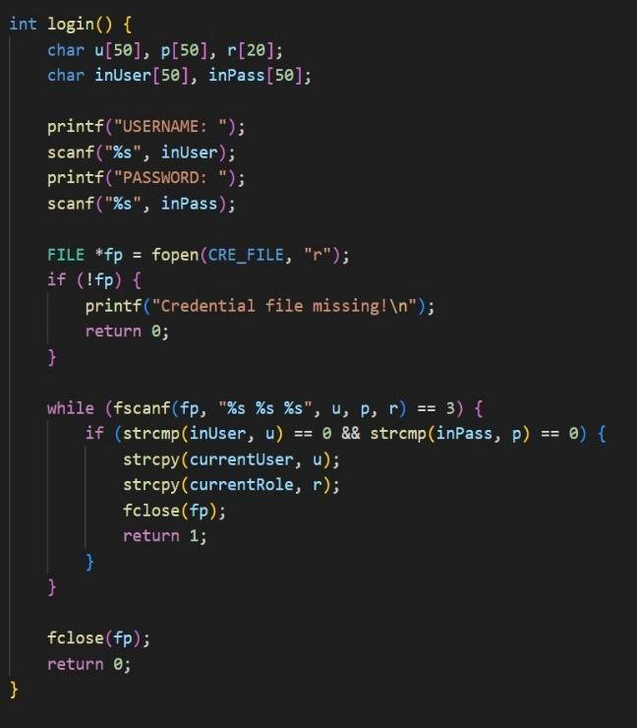

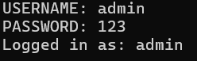

MENU MODULE (ADMIN)
The admin menu provides full system control, including add, display, search, update, and delete operations.
It loops continuously until the user selects the logout option.

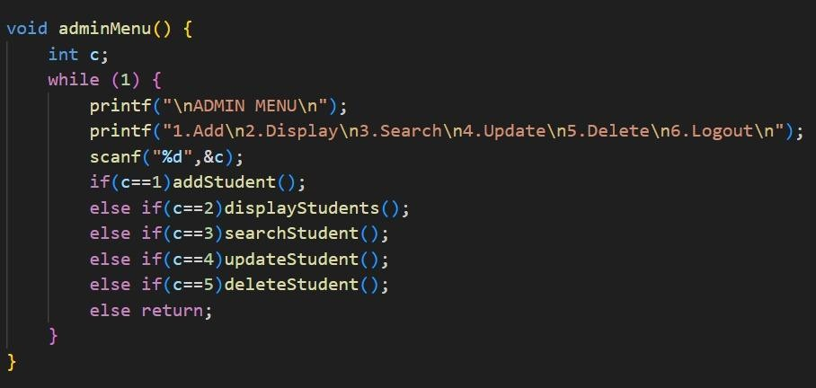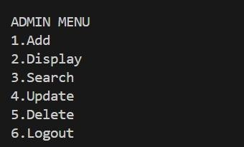

ADD STUDENT
The addStudent() function allows the user to input roll number, name, and marks, then stores the record in the student data file.
It uses append-mode file writing to ensure new entries are added without overwriting existing data.
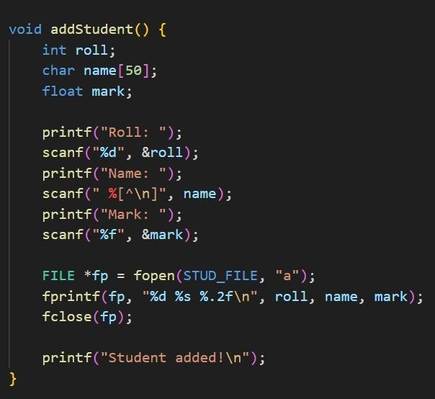

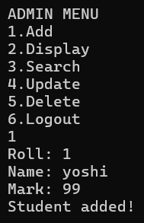

Display student
The displayStudents() function reads all stored records from the students file and prints them in a tabular format.
It ensures that every saved entry is visible to users across all roles.

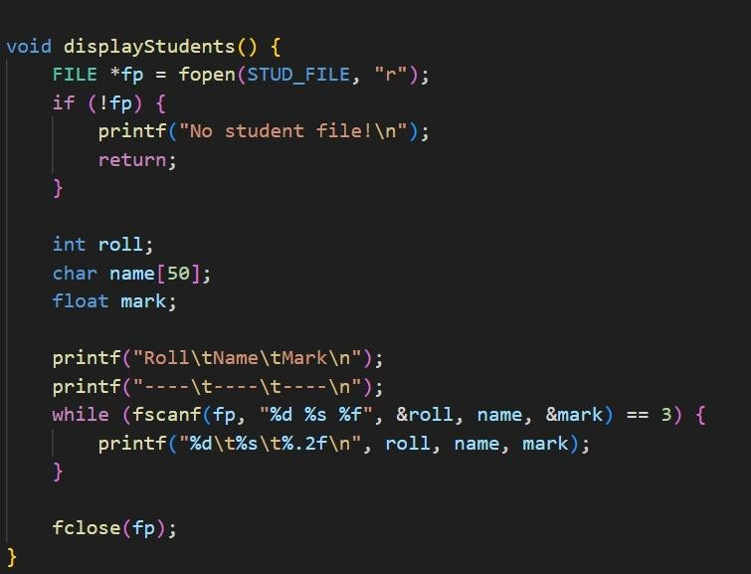

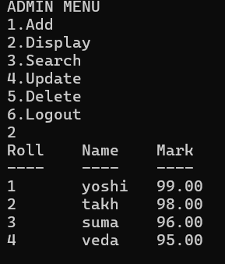

Search student
The searchStudent() function searches for a student by roll number and displays the corresponding record if found.
It performs a sequential file scan and stops immediately when a matching roll is identified.

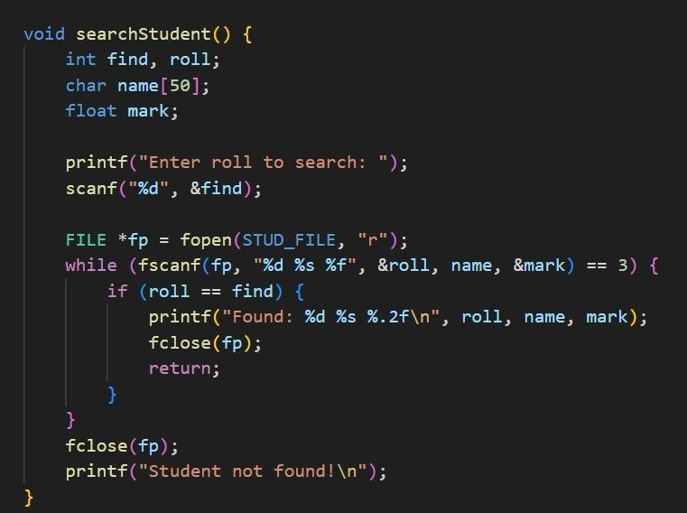

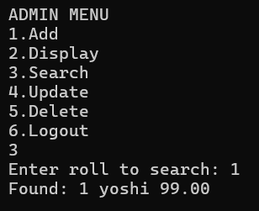

Delete student
The deleteStudent() function removes a student record by copying all other records into a temporary file.
This method ensures accurate deletion without affecting remaining student entries.
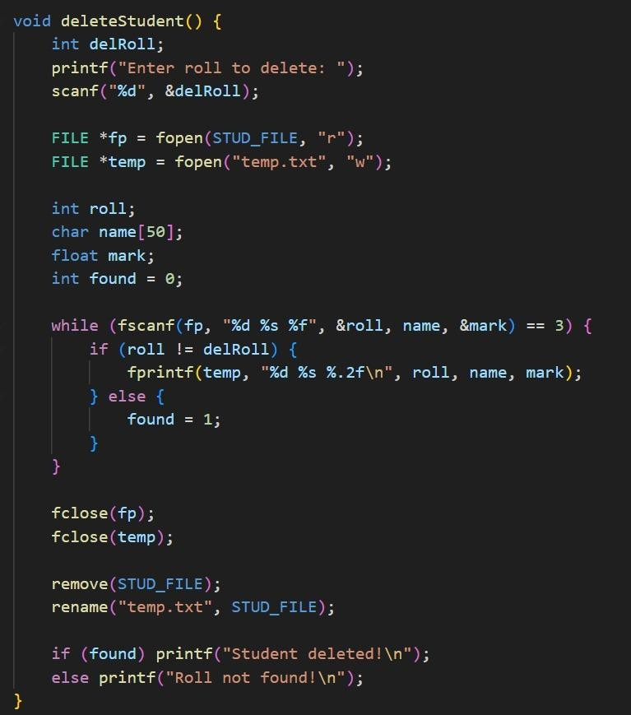

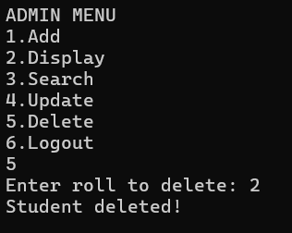

Update student
The updateStudent() function modifies an existing student record by rewriting updated details into a temporary file.
Once updated, the original file is replaced to maintain data consistency.

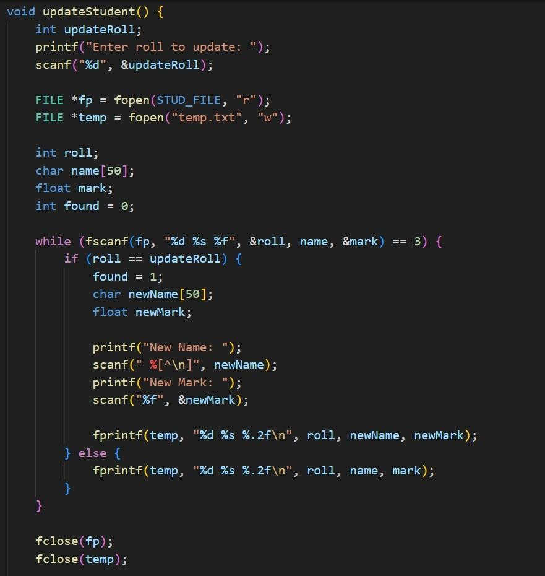

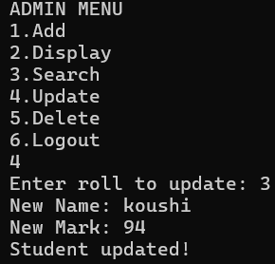

CODE&OUTPUTS

✓ student.txt

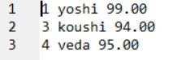

✓

credentials.txt

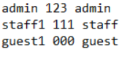

CONCLUSION:
The Student Management System implemented in C provides an efficient and user-friendly solution for managing student records. Through the integration of login authentication, role-based access, and modular programming, the system ensures secure, organized, and streamlined handling of student data. The project demonstrates practical application of core C programming concepts such as file handling, arrays, functions, and control structures. Overall, this system not only simplifies administrative tasks but also serves as a foundation for further enhancements, such as database integration and graphical user interface development, showcasing the potential for scalability and real-world utility.

